LAB

REPORT

CSE 114 : Data Structure and Algorithms Sessional

|  |  |
| --- | --- |
| PREPARED BY  Mehrin Farzana  ID: 2101013  Session: 2021-2022  Date: 11/10/2023 | SUPERVISED BY  Suman Saha  Lecturer  Department of IRE, BDU |

|  |  |
| --- | --- |
| logo1 | BANGABANDHU SHEIKH MUJIBUR RAHMAN DIGITAL UNIVERSITY  (BDU) |
|  |  |

**List of Problems**

1. Quick sort.
2. Heap sort.

**Problem No.:** 01

**Problem Statement:**

Quick sort.

.

**Code:**

#include <stdio.h>

void quick_sort(int *a, int lb, int ub){

if (lb>ub) return;

int pivot = a[lb];

int start = lb, end = ub;

for(start; start<end; start++){

if(a[start]>pivot){

if(a[end]<pivot){

int temp = a[end];

a[end] = a[start];

a[start] = temp;

}

end--;

start--;

}

}

if(a[end]>pivot){

end--;

int temp = a[end];

a[end] = a[lb];

a[lb] = temp;

}

else if(a[end]<pivot){

int temp = a[end];

a[end] = a[lb];

a[lb] = temp;

}

quick_sort(a,lb,end-1);

quick_sort(a,end+1,ub);

}

int main() {

int n;

scanf("%d", &n);

int a[n];

for(int i=0; i<n; i++){

scanf("%d", &a[i]);

}

quick_sort(a,0,n-1);

for(int i=0; i<n; i++)

printf("%d ", a[i]);

return 0;

}

**Output:**

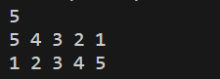

Fig 1.1: Output on console for case 1.

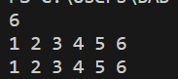

Fig 1.2: Output on console for case 2.

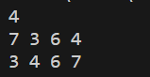

Fig 1.3: Output on console for case 3.

**Problem No.:** 02

**Problem Statement:**

Heap sort.

.

**Code:**

#include <stdio.h>

void swap(int* a, int* b)

{

int temp = *a;

*a = *b;

*b = temp;

}

void heapify(int arr[], int N, int i)

{

int largest = i;

int left = 2 * i + 1;

int right = 2 * i + 2;

if (left < N && arr[left] > arr[largest])

largest = left;

if (right < N && arr[right] > arr[largest])

largest = right;

if (largest != i) {

swap(&arr[i], &arr[largest]);

heapify(arr, N, largest);

}

}

void heap_sort(int arr[], int N)

{

for (int i = N / 2 - 1; i >= 0; i--)

heapify(arr, N, i);

for (int i = N - 1; i >= 0; i--) {

swap(&arr[0], &arr[i]);

heapify(arr, i, 0);

}

}

void printArray(int arr[], int N)

{

for (int i = 0; i < N; i++)

printf("%d ", arr[i]);

printf("\n");

}

int main()

{

int n;

scanf("%d", &n);

int a[n];

for(int i=0; i<n; i++){

scanf("%d", &a[i]);

}

heap_sort(a,n);

for(int i=0; i<n; i++)

printf("%d ", a[i]);

return 0;

}

**Output:**

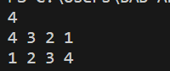

Fig 1.1: Output on console for case 1.

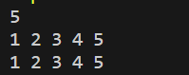

Fig 1.2: Output on console for case 2.

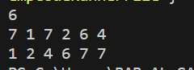

Fig 1.3: Output on console for case 3.